To see the fretboard, where you can add, change delete notes, you first of all
select an individual track on the normal track view page (the page that comes up showing your tracks when you open a song).

The go to View and select Staff

Then when your notes are showing on the staff, click the Fret View icon (or just hit V) to see the fretboard

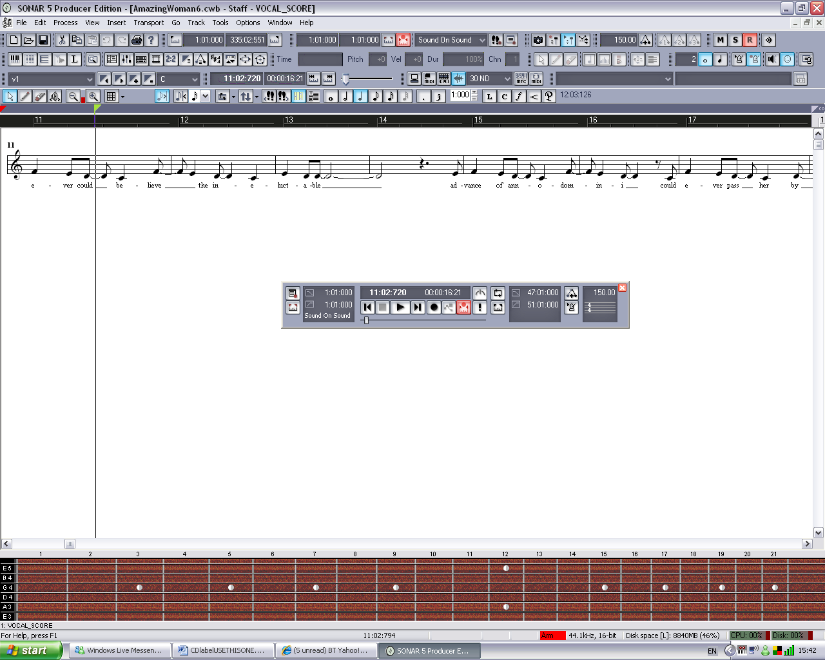

You can add notes here and see them on the staff and you can export them to an asci file by click the TAB icon next to the Fret View icon

If you right click the fretboard itself you can choose the wood style and even mirror for left handers!!!

