Kerry George BA (Hons) ARAD. RTS.
Assoc ISTD
01252 641561 / 07960 069988
kezzygeorge@hotmail.com
98 St Michael’s Road, Aldershot, Hants, GU12 4JW
Issue 12
September 2011

LAFOUR FARNBOROUGH NEWSLETTER

Dear Parents and Students

Welcome back, I hope you all had a wonderful Summer and are feeling rested and full of energy. We have a busy term with Modern and Tap exams taking place so please read on.

Studio & Club Etiquette
Just a reminder, please can you ensure that you change your children in the changing rooms, not in the gym as this causes complaints from other members. Many thanks for your co-operation.

Please can I request that all Ballet girls who are Grade 4 and above ensure their hair is fixed up in a bun, it is impossible to practice pirouettes (turns) if their hair is not up.

2011/2012 TERM DATES FOR YOUR DIARY
Winter term – 12th September –10th December. Half-term w/c 24th October
Spring term – 3rd January – 31st March. Half-term w/c 13th February
Summer term – 16th April-14th July. Half-term (1st Saturday off, NO classes on 2nd June, recommence Saturday 9th June) – Summer School Monday 30th July – Thursday 2nd August 2012

Class Timetable Winter Term 2011
Fridays at Farnborough Virgin Active
4.00-4.30 pm Grade 2 Modern
4.30-5.15 pm Grade 3 Modern
5.15-5.45 pm Silver Jazz
5.45-6.30 pm Grade 4 Modern
6.30-7.30 pm Grade 5 Modern

Mondays at Wavell Cody
7.00-8.00 pm Intermediate Foundation Ballet

Tuesdays at Wavell Cody
5.35-6.20 pm XDC Performance Class
Saturdays at Farnborough Virgin Active
9.15-9.45 am First Steps
9.45-10.15 am Pre-Primary Ballet
10.15-10.45 am Primary Ballet
12.00-12.45 pm Grade 1 Ballet
12.45-1.30 pm Grade 2 Ballet
1.30-2.15 pm Grade 4 Ballet
2.15-3.15pm Grade 5 Ballet
3.15-4.30 pm Grade 6 Ballet

6.20-7.05 pm Grade 4 Tap

Tuesdays at Farnborough Virgin Active
4.00-4.30 pm Grade 1 Tap
4.30-5.15 pm Grade 3 Tap
5.15-6.00 pm Grade 2 Tap

Modern
All our Grade 1 Modern girls did extremely well in their exam last term
Isabella Broxis Distinction
Caitlin Dennard Distinction
Abigail Eason Distinction
Hayley Waterlow Distinction
Abbie Westwood Distinction
VERY WELL DONE girls, we are very proud of you.

We have Modern exams this term for Grades 3/4/5 this term on either the 2nd or 6th of November, details have been circulated, we wish you all the very best of luck.
Tap
Tap exams are being held for Grades 1/2/4 again on either the 2nd or 6th November, details have been circulated, work hard and I am sure you will all do very well.

Ballet Exams
RAD Ballet exams took place at the end of term last term and again some excellent results, 100% pass rate with 97% of students achieving Distinction or Merit, Well Done Everyone.
Note on uniform for Grade 4 girls, next time you need a new leotard you will need a Roch Valley Camille in Damson, I can get these cheaper than the shops £17.00.

Our XDC students are going to be studying Revelations by Alvin Ailey this term, so a return to Contemporary and the prospect of an exciting performance piece.

Summer School
Was held from the 1st –4th August at Wavell Cody Campus for students Grade 1 and above. We all had a marvellous time, the temperatures soared and so did our dancing! We did daily classes in Pilates/Body Conditioning/Stretching, Modern, Jazz, Ballet, Tap and Contemporary, plus we did a dance quiz every lunchtime in teams. Luckily the teams drew on day 4 so we all got to eat Minstrels!
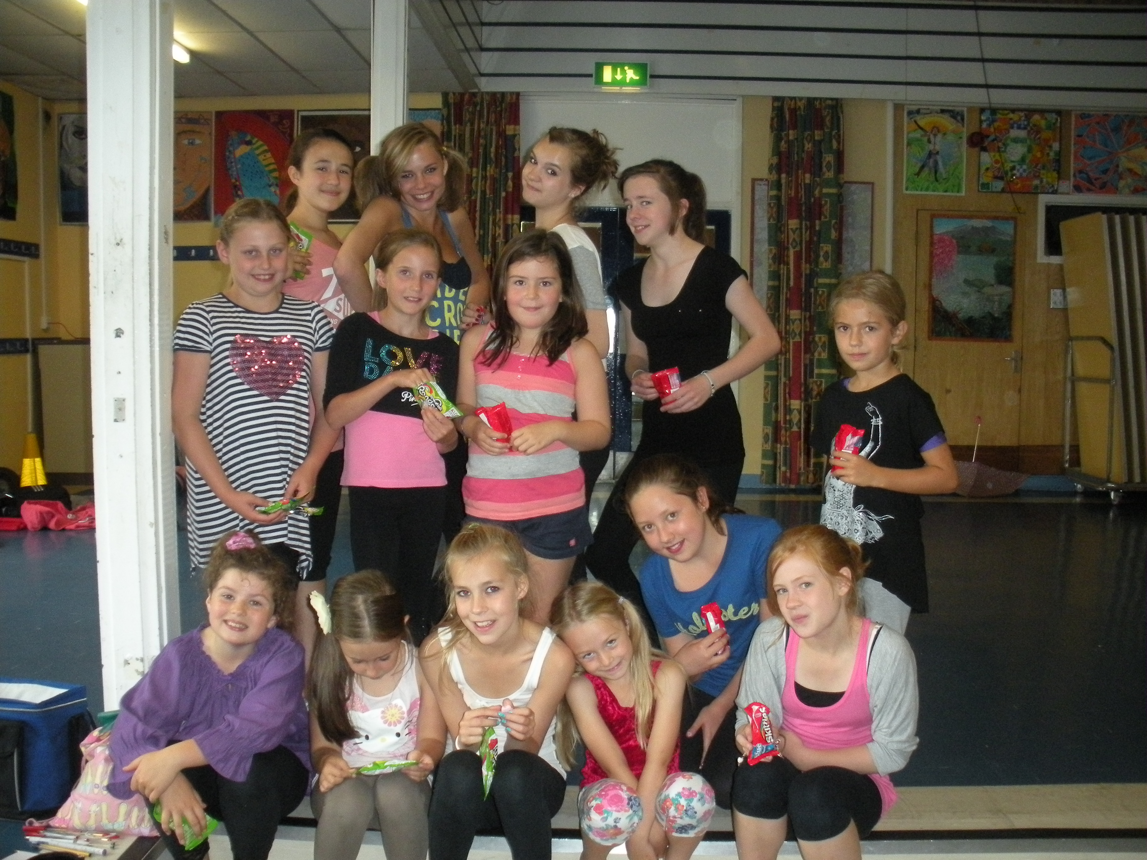
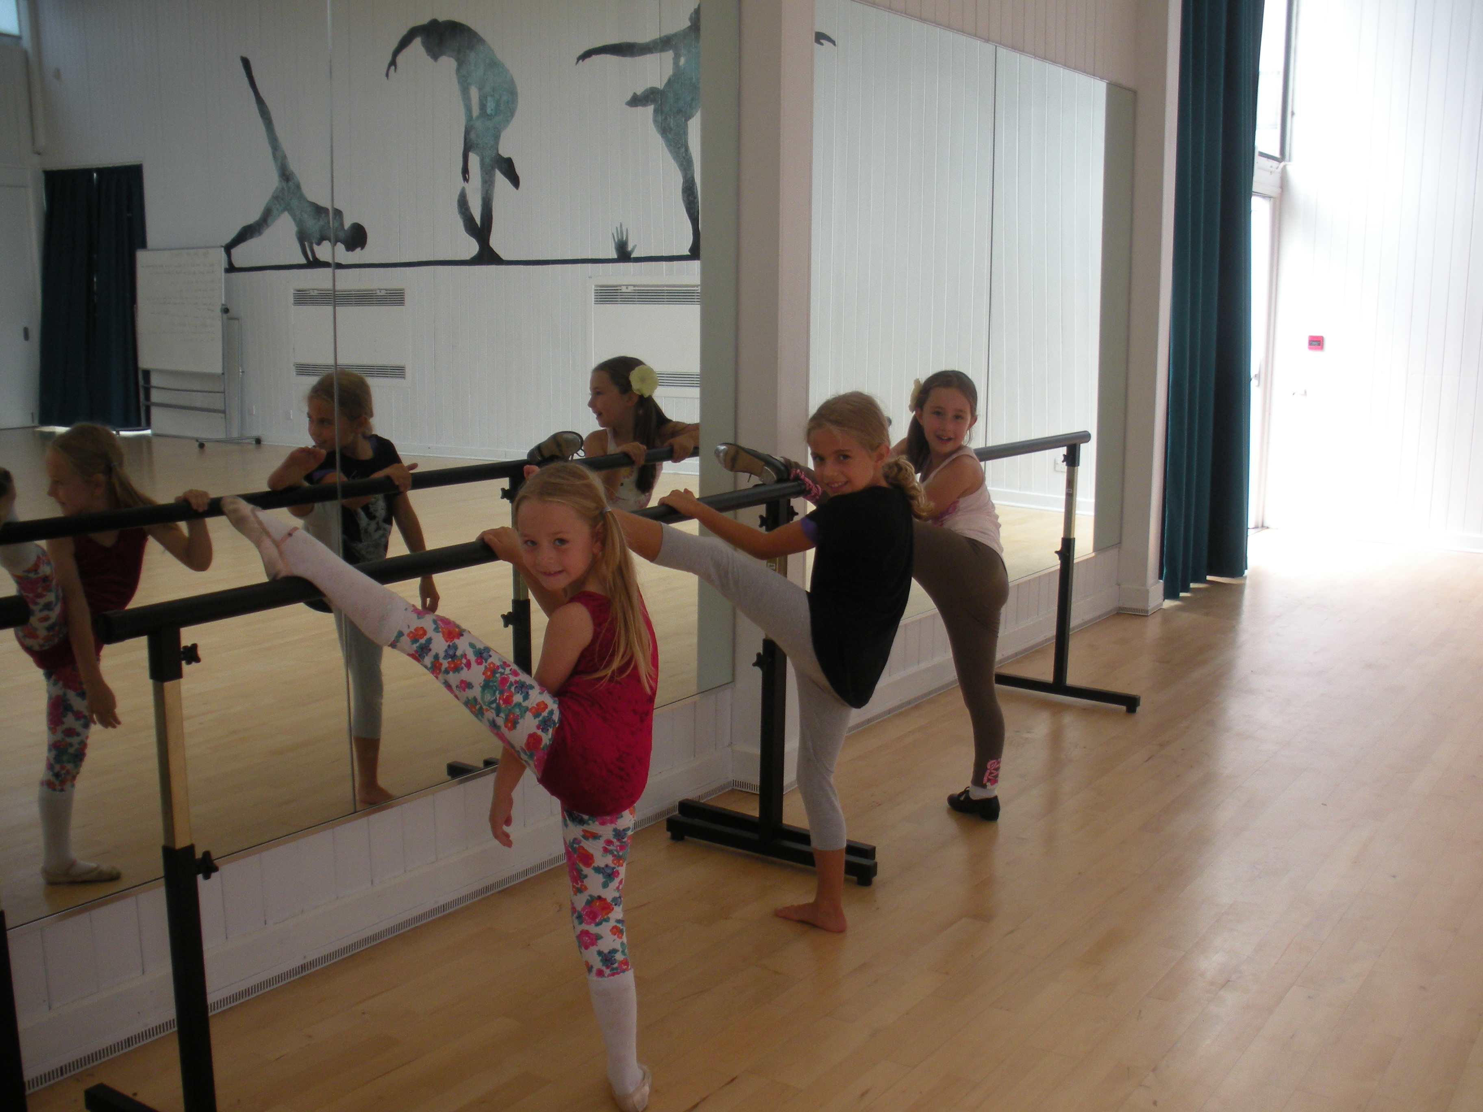
I thought I would share some of the comments from students with you:
‘Summer School was awesome!! It’s been so much fun and contemporary is BEAST!’ ‘It was fun because we did lots of different dances.’ ‘I would do it again next year’ ‘Really fun, I’d do it again!!! There were fun stretches and the lessons were well spread out’ ‘I loved everything in Summer School, I want to go again!!!’ ‘Summer School was so much fun, I loved seeing all my friends at dancing’ ‘Summer School was amazing I really enjoyed it! You should run it next year.’ ‘I hope it will carry on next year.’ ‘I enjoyed EVERYTING about summer camp.’ ‘I enjoyed EVERYTHING in Summer Camp!!!!!!’
And just to confirm we will be holding Summer School again next year from Monday 30th July-Thursday 2nd August for all of you who do the planning. Spaces will be limited so ensure you book early.

So a busy term for a lot of our students, work hard and I am sure all your efforts will be rewarded.
As always, a big thank you to all parents for your help and support, we couldn’t do it without you.
Photographs from the April 2011 Show are now on the Lafour website www.lafour.org.uk
Kerry

